CST8215 – Lab 11 Submission

Student Number: _______41019241__________

Student Name: ________Adam Di Cioccio______

Section Number: __321__ (e.g. 322, 323, 363)

Date: __November 30, 2020___

Procedure

Where you see *Provide screenshot here* you are being asked to take the screenshot from PG Admin (both the top pane where you have typed in the SQL statement and the bottom pane showing the results of the SQL statement)

Submission

Using the Lab 11 Instructions (set of code), you will see there is a trigger created called ‘trigger_test’ with its related function named ‘trigger_testing’.

Once you have completed running all the sql statements, make the following changes and for every change, provide screenshots as requested.

*Hint --- if you keep all the statements in a single SQL window then it is simpler to see the steps and how they relate / depend on each other.*

**Question 1** – In step 3 (create the trigger function) change the part of the INSERT statement

from ‘(new.id)’

to ‘(new.log_id)’

execute the full DML command and attempt to insert a new row into the employee table.

Provide a screenshot showing the results.

*Provide screenshot here*

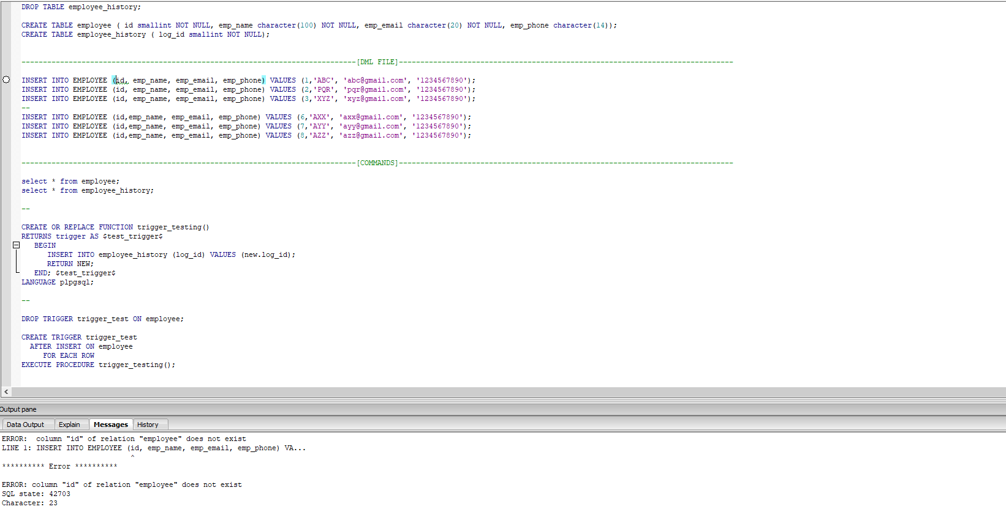

**Question 2** – If there was an error, make the change necessary to the employee table (**not the trigger**) to correct the error….

Provide the steps that you used (and corresponding screenshots showing the script and result set) to ensure the full set of commands run error free.

*Provide screenshots here*

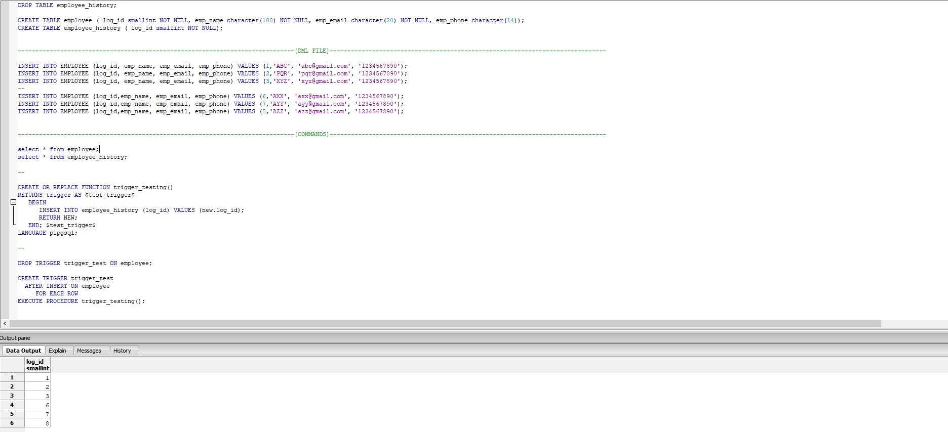

**Question 3** – In step 4 (create the trigger) change AFTER INSERT to AFTER UPDATE

Drop and recreate the trigger. Execute an INSERT statement and check the contents of the employee_history table for the new row.

If this new row is not appearing in the employee_history table, write your explanation below as to why the row is not showing up in the employee history after you have changed the ‘event’ in the trigger.

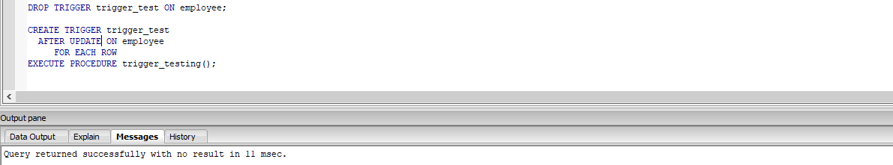

The reason the rows aren’t showing up because the trigger is now setup to only run when an update statement is used and when we run the insert statements it isn’t classified as an update so it doesn’t utilize the function / trigger.